xpedx.com Next generation
Shopping Cart Detail Design Document

Authors: Sterling Commerce

Date Created: 04/12/10
Last Updated: 06/17/10
File Name: C:\Documents and Settings\bfurman\My Documents\Temp\Methodology v1.1\Project Management\TEMPLATE - DOCUMENT - Use Case Definition.doc0000.doc

Approval Signatures (Mandatory)

Title | Name | Signature | Date | Comments / Issues / Concerns
xpedx Owner(s) | Steve Bugher
xpedx Owner(s) | Cheryl Tullis
Sterling Commerce Owner(s) | Guy Read

Note: The sign off indicates approval of all sections of the document.

Document Revision History

This chart tracks the changes introduced by the revisions to the document as the project progresses through the stages of the System Development Life Cycle (SDLC).

Version | Date | Description (Changes Made) | Author(s)
1.0 | 04/12/2010 | Initial Draft | Sterling
1.1 | 04/16/2010 | Ready to deliver | Sterling
1.2 | 05/25/10 | Feedback incorporated | Sterling
1.3 | 06/02/10 | Incorporated changes from 6/1/10 meeting with Steve, George and Chris, Cheryl and Jasmine | Sterling
1.4 | 06/08/2010 | Question related to Special offer has been answered after talking to Steve, George and Jasmine | Sterling
1.5 | 06/11/2010 | More feedbacks | Sterling
1.6 | 06/15/2010 | Quick Add process has been revised | Sterling
1.7 | 06/17/2010 | Minor Verbiage Changes | Sterling
1.8 | 06/22/2010 | Minor Updates | Sterling
1.9 | 07/06/2010 | Order Minimum | Sterling

Related or Reference Documents

Document Name | Description | Owner | Location
SCI_Xpedx Solution Definition Document v1.5 | Solution Definition document | Sterling Commerce

TABLE OF CONTENTS

1. Introduction 4
1.1 Document Purpose 4
1.2 Document Audience 4
2 Shopping Cart 5
2.1 Functions & Solution 5
2.1.1 Shopping Cart List Page 5
2.1.2 Shopping Cart Detail Page 6
2.1.3 Quick Add to Shopping Cart 6
2.1.4 Add Items from other pages 7
2.1.5 Mini Cart 7
2.2 Master System 7
2.3 Implementation Details 7
2.3.1 Entity objects. 7
2.3.2 Actions involved and Functions 7
2.3.3 API Details 8
2.4 Process Flow 8
2.5 Screen Shot 9
2.6 Open Questions 12
2.7 Assumptions 13
3 Glossary of Terms 14

Introduction

Document Purpose

This document is the governing functional design document for Shopping Cart functionality. It presents significant decisions and constructs used in developing the functionality. Testing, builds, configuration management are not covered in this document.

The document will also serve the purpose of keeping a list of assumptions that were made during design discussions.

Document Audience

This document is intended for management and technical staff working on this project, xpedx IT and Business, webMethods, Legacy(MAX and ACCESS), HP, IW, xpedx/IP Network Team. Sterling will use the document during design and configuration for design consideration.

Shopping Cart

Functions & Solution

Shopping cart is a draft open order which contains a list of items the user wants to order. Users can have multiple Shopping Carts but one cart will be active. Users will have only one active cart regardless of browsers. There is provision for the user to select a cart and make it the active cart through cart management. Once a cart is ordered it is no more a draft / open order.
New cart can be created from the Shopping cart Page (Create new cart/ copy cart) functionality
These are the ways the user can add items to their Cart.
- Browse / Search catalog and add items
- Add from the Item Details Page
- Add from the Item Compare Page
- Add from the Order detail (History) Page
- Quick Add from the List Details Page.
- My Items List
- B2B requests
- Adding special items to the cart.
The user should only see the Carts for the Ship To they have selected. They can change the ship To from the drop down that way they will select a different ship to see the carts for that ship To provided the user has access to that ship To.

Shopping Cart List Page

This page displays all the draft orders for the logged in users. The Cart List page will be paginated and the page size will be 50. The recent orders list page is showing 50 orders at a time. Let’s keep everything to that. The following fields will be shown as column headers on the Cart page, and the columns headers are sort able. Please refer to screen shot ‘My Cart List Page’ in the Screen Shot section of the document.

- Cart Name & Description along with Number of items in the Cart – Cart name does not need to be unique same as My items list.
- Modified By
- Last Modified Date
- Actions – The following actions are permitted at the Cart List level
  - Open Cart – Goes to the Cart Detail page.
  - Copy Cart – Copies the items from the existing Cart to a New Cart. A new Cart Name and Description is required during the new Cart creation. We have already coded for the cart description as custom field, since it was not OOTB.
  - Delete Cart – Deletes the Cart.
Header Level Actions - Create New Cart.

Shopping Cart Detail Page

This page displays the details of a particular cart. P&A is done automatically when the details page is rendered. In the P&A request both the stock and non-stock items are sent. These types of products are in the catalog. Special products are not in the catalog and no P&A check will be done for those. Alternate & Replacement items from the customer’s ship from division are presented as other buying options to the user against the line items in the cart if there are alternate and replacement items for the same.

This page also shows Related Items which are nothing but cross-sell and up-sell items and alternate items related to the items in the cart. The Cross-Sell and Up-Sell items are fetched from the item definition set at the national level as well as Complimentary (cross-sell) and Upgrades (up-sell) items from the division item feed. The special offer space in the cart page is a real state area for Advertisement, which will be fetched as a link on the page from some xpedx web server. Please refer to the screen shot ‘Shopping Cart Detail Page’ in the Screen shot section of the document. The following actions can be performed from the cart detail page.

- Edit the name and description of the Cart
- Quick Add
- Remove items
- Add Items to List – Add selective items from the cart to a new My Item List or an existing List
- Update Price and Availability – whenever the button is clicked. The other update / save button will not call P&A that is to just save changes on the line.
- Update button.
- Add line level notes / instructions.
- Change UOM / Quantity
- Enter Line Account Number, CustomField1, CustomField2, CustomField3, Customer Line PO# and Customer Sequence #. First four fields customer defined labels. Max Length on the label is 20 characters. Fields and label displays based on customer profile setting.
- Select All features for checkbox.
- My Price shows the customer selected UOM Price and the Pricing UOM Price. Include UOM and only show one if the UOM’s are the same
- Adjustments
- Line Total
- Availability – please refer to the Inventory Calc and Transfer Circles logic for the display logic.

Quick Add to Shopping Cart

Quick Add is one of the channels to add items to the cart. Item Validations will be done as part of the add process. Copy and Paste is another quick way to add items to the Cart. When the user clicks on the Copy & Paste link in the Quick add window, a modal will open up and the user can enter xpedx# and qty and click add to cart.

Steps for Quick Add:
- User can enter Customer Line fields, Qty, Item#, Item type, and then select Add to Quick List.
- Item type options would be one of the following based on customer profile: xpedx #, customer part #, MPC #, Manufacturer #.
- Before adding the item to Quick list, the items are validated and the valid UOM are populated. If the item doesn’t exist in the catalog then the message will be displayed.
- There will be button to add the items to cart.

Add Items from other pages

Users can browse the catalog or search items from the catalog and can add it to their cart. The option for adding items t the cart will also be available from the Item details page and Compare Page. By default the items are added to the active cart.

Mini Cart

The Mini cart functionality enables users to get a quick view of the contents of their shopping cart without navigating to the Cart Detail page. Users can view the contents of their default cart from any page. For example, when a user is performing an advanced search for a product in a catalog, the user can also view the contents of the default cart, add products to the cart, or delete products from the cart in the Catalog Advanced Search page. A user can move the pointer over the mini cart hyperlink and view the expanded mini cart. If a user has multiple carts, the user's active cart is displayed as the mini cart. As part of this functionality, the application navigation bar displays the order subtotal and the number of major line products in the cart as hyperlinks to enable a user to navigate quickly to the Cart Detail page. From the expanded mini cart, a user can perform the following tasks:

- Navigate to the Product Detail page of a line item
- Navigate to the Shopping Cart List page
- Delete line item
- Modify line item quantities

Order Minimum Value.

When a minimum order value is not met, one of two actions will be taken based on the value for the customer in the customer profile for minimum order value.
- Either the order will be hard stopped in Web Channel until the minimum order value is met.
- An additional order charge will be added to the order as specified in the customer profile.

Order Maximum Value.

When an order exceeds the Order Maximum value, as specified in the customer profile for that customer, the order will go on Web Channel hard stop until the order value is reduced below the Order Maximum Value

Master System
Sterling is the master of system to maintain and create Shopping Carts.

Implementation Details

Entity objects.
OOTB entity object is extended to add the following field. The entity name is XPX_ORDER_Extensions.
- Cart Description
- Customer User Fields 1, 2, 3 and Customer Line Account Number – The job# is a label for one of this field (most probably Customer Line Account Number)
- Item Type

Actions involved and Functions
Following new Actions are introduced to achieve the required functionality on top of OOTB
- XPEDXDraftOrderListAction.java – This action is responsible to get the list of open carts.
- XPEDXDraftOrderDetailAction.java – This action is responsible to get the cart details.
- XPEDXQuickAddAction.java – This action is called from the quick add widget when user tries to add items to the quick list and cart.
- XPEDXQuickAddCopyPasteAction.java – This action is called from the copy paste widget when user tries to add items to the quick list and cart.

API Details
Following APIs will be called to achieve the functionality.

- getCompleteItemList – To get the Item Details of an item.
- getcompleteOrderdetails -get the details of the cart.
- changeOrder - to change and update cart details.
- deleteOrderLine – to delete a line in the cart.
- deleteOrder – to delete a cart.

Process Flow

Not Applicable

Screen Shot

The screen shots pasted here are still in review and not final. This is just an illustration of how it should look like.

Shopping Cart List Page
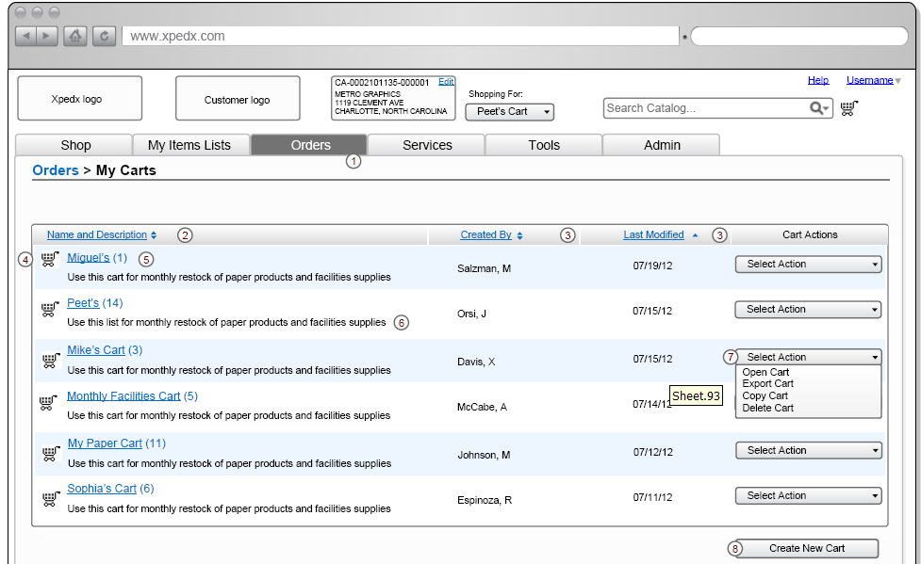

Shopping Cart Detail Page

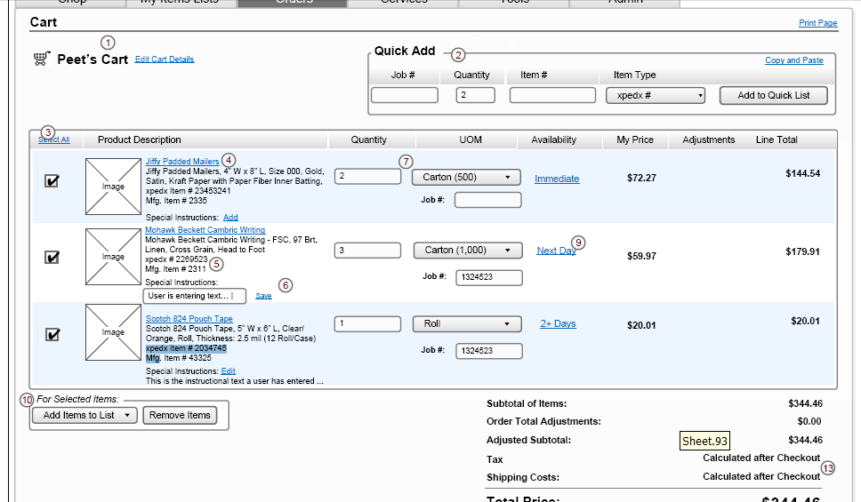

Product Detail Page

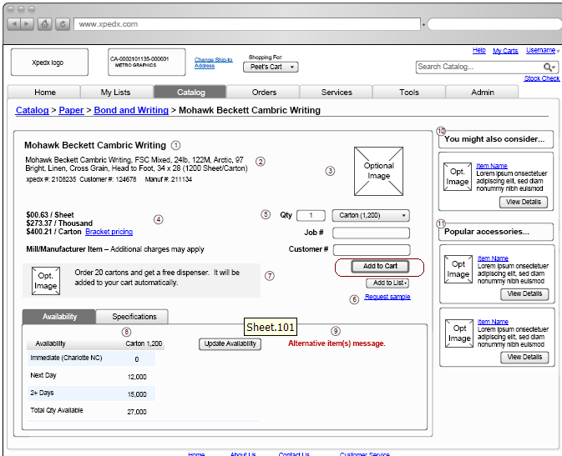

Catalog Page
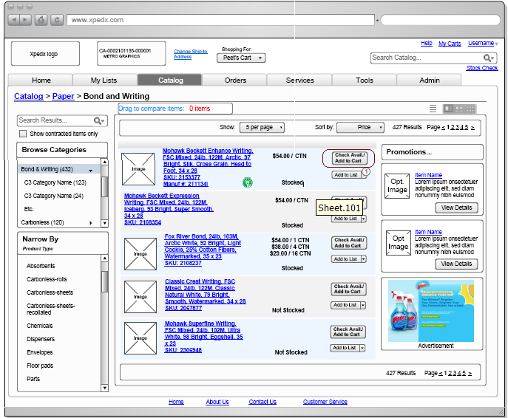

Open Questions
- What is the expected behavior for the export cart functionality? Answer: This is out of scope
- Special Offers functionality needs to be evaluated, are these promotions for the items in the List? Answer: Confirmed with Steve, George and Jasmine – This is just an advertisement real state on the Sterling Cart and My Items List Page and the page will have a link to an external web server which will host the advertisement. The link will fetch the advertisement and render it on the page.
- Why do we have the Cart List Actions in the Shopping Cart Detail Page? Answer: xpedx proposed they should remove the List actions from the detail page. This should be more like what OOTB supports.
- Need to understand how to roll up inventory results coming from P&A and show them in the hover proposed by IW. Answer: Resolved.
- Can we have the update button as line level action instead of a global action? If not the user has to choose the select box on the left and then modify the line and click save. Answer: Global save/update button is fine.
- What is the process to purge carts? Answer: There is no process for purging open shopping carts in Sterling.
- Quick Add process needs to be defined by xpedx, there is no clear process as how the quick add should behave for items in the catalog and special items, Xpedx to come back. Answer: When the user enters the item and click add to quick list, the item will be validated and if the item is not valid in the catalog then the message of invalid item and check the number will be shown. Special(non catalog items) will not be entered from quick add. These can be only entered from the catalog. A link will be provided to enter the item. The screen is on page 16 MIL/Cart wireframes. They can add this item to cart from this screen.
- Should we still have a 2 step process of first adding the items in the quick list and then when the user clicks on add to cart button, then add the items to the cart, or should we skip the quick list temporary step.
- Xpedx to send us modified screen shots for the mini cart functionality. – Clarification from Sterling about default cart / mini cart. The default cart is the cart the last time the user has accessed or modified. This is the cart of the logged in user and does not depend on the Ship-To. If a default cart is not found it creates a new cart.

Assumptions
- Availability information is not stored in the session, every time the availability needs to be shown for the Shopping Cart Detail page, the interface needs to be invoked.
- When the customer adds an item through quick add and choose item type to be xpedx# or manufacturer # we will look into the corresponding filed to query. We are not going to query based on all the possible item types. MPC Code and Customer Part # will be other options to add items as item type.
- Related product carousel at the bottom of the Shopping Cart detail is a collection of all the Cross-Sell and Up-Sell items from the item master feed from data point at the national level. As well as Complimentary (cross-sell) and Upgrades (up-sell) items from the division item feed.
- Duplicate item lines will not be checked either in the List or in the Cart or during add to cart. If the user has more than one lines for the same item, they will appear more than once and no quantity consolidation or merging will happen.
- Business rules as described in this and the Order Holds in Call Center Detailed Design document section 2.4.2 will be enforced in the Web Channel order creation to prevent creation of invalid orders that will go into hold status in Call Center

Glossary of Terms

S. No. | Term | Definition
1. | Entity Object | Database and Java entity objects to store the required data.
2. | Action Class | Struts controllers which redirects the parameters and does some business logic before calling the business APIs.
3. | BR1 | Business Release 1
4. | IW | Industrial Wisdom – UI firm engaged on the project.
5. | Quick Add | Quick way of adding items to the cart or list.
6. | OOTB | Out of the Box Sterling system

